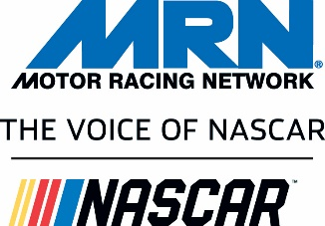

February 1, 2018

RE: MRN-NASCAR and Series Logo Usage

Dear Radio Partner,

In 2017 NASCAR rebranded their logo as you can see above in our “Voice of NASCAR” logo. They are still transitioning with their partners and we do not yet have a style guide or short-form program logos. We expect them to be completed by mid-season. If you don’t see a logo you’re looking for, please contact MRN at (704) 262-6712 for assistance.

Available .eps and/or .png formatted logos:

- Monster Energy NASCAR Cup Series
- NASCAR Xfinity Series
- NASCAR Camping World Truck Series
- MRN – Voice of NASCAR (horizontal)
- MRN – Voice of NASCAR (verticle)
- NASCAR Live
- NASCAR Today (for NASCAR Today and Midday)
- NASCAR U.S.A.
- Monday Morning Race Recap
- World of Racing

Usage:

- You may use the NASCAR Series and MRN show logos to promote your local coverage in conjunction with your brand identity in newspaper, online, and through social media
  - Usage for promotional purposes only
  - You may not alter any of the logos in any way
- You may use the MRN-Voice of NASCAR logos to promote your local coverage in conjunction with your brand identity in newspaper, online, social media, on station vehicles, and on promotional apparel (for other usage please call MRN)
  - Usage for promotional purposes only
  - You may not separate or use any one portion of the logo without the others
  - You may not alter any of the logos in any way

As NASCAR continues to transition and our logos become updated, you can find them in the Radio Partners section at MRN.com. We’ll let you know as soon as they become available.

555 MRN Dr., NW, Concord, NC 28027 (704) 262-6712 www.MRN.com

